TENDER
for
Fabrication & assembly, testing and delivery
Of
Animal Rescue & transport Vehicles at selected locations in India

Tender Number: 91134392
Date: 19.11.2019

(Single Envelop Bid System)

Particulars | Description
Purpose of Tender | To select an experienced company for fabrication & assembly, testing and delivery of Animal Rescue & transport Vehicles at selected locations in India
Tender reference number | 91134392
Date of tender announcement | 19.11.2019
Last date to submit pre-bid queries by the interested bidders | 23.11.2019
Last date to provide clarification to the queries. All the queries will be answered in the form of (Frequently asked question) FAQ and will be uploaded on the website www.tendernews.com | 25.11.2019
Last Date and time for submission of bids | 29.11.2019
Mode of Submission | Technical and Financial bids to be submitted in sealed envelope as per the given instructions.
Validity of Bids/ Offered Price | 60 days from the last date of submission of bids 29.11.2019  The selected supplier shall not be able to vary from their financial bid until the completion of the Order, if awarded by GIZ.
Address for Bid Submission | The Head of Procurement  GIZ Office, 46, Paschimi Marg  Vasant Vihar, New Delhi-110057
Location of Site | Kodagu Forest Circle in Karnataka  Haridwar Forest Division in Uttarakhand
Dear Sir/ Madam

Technical and Financial bid in sealed single envelop are invited on or before last date for submission of bids from experienced companies for fabrication & assembly, testing and delivery of Animal Rescue & transport Vehicles at selected locations in India.
The bid may be prepared as per the provisions mentioned in the following documents available:

- Invitation to Tender- Scope of work and bidding conditions

- Design and Specifications for fabrication – Annexure “1”

- Covering Letter from Bidder – Annexure “2”

- Declaration by bidder – Annexure “3”
- Document Submission – Annexure “4”
- Delivery Schedule – Annexure “5”
- Financial Bid (Submission of Price) - Annexure “6” A & B
- General Terms and Conditions

We look forward to receiving your offers.

With best regards,

Procurement Department
GIZ Office, New Delhi

Project Overview

Background

Deutsche Gesellschaft für Internationale Zusammenarbeit (GIZ) GmbH is a German Government enterprise that provides services in the field of international development cooperation worldwide. In India, GIZ has been working jointly with partners for sustainable economic, ecological and social development since more than 60 years now.

The project “Human Wildlife Conflict Mitigation” is supported by the German Federal Ministry for Economic Cooperation and Development (BMZ) and implemented by the Ministry of Environment, Forest and Climate Change (MoEFCC), Government of India and Deutsche Gesellschaft für Internationale Zusammenarbeit (GIZ).

The project aims at providing technical support at the National level and in selected States for effective implementation of Human Wildlife Conflict mitigation measures. The project outcome is that “The rural population in project areas, where agreed guidelines and tools are applied to mitigate human wildlife conflicts, is better protected against human wildlife conflict”. The project takes the approach of harmonious coexistence, by ensuring that both – human and wildlife – are protected from conflicts. This approach follows the modern wildlife conservation principles to balance the needs of people with the conservation of nature.

The project is being implemented at the National level, and in three Partner States: Uttarakhand, Karnataka and West Bengal.

The specific project pilot sites of the project are: Haridwar Forest Division in Uttarakhand, Gorumara Wildlife Division in West Bengal, and Kodagu Forest Circle in Karnataka.

Present Scenario

The removal of a problem animals through translocation is being used in several parts of the World, as well as in India. Usually elephants are tranquilised and transported to a new location on specially adapted vehicles, where they are released. Translocation is a humane management alternative to killing problem elephants.

Translocation becomes a challenge when it comes to elephant or even more when few members of the herd are to be translocated together. Heavy duty vehicles with specialized features to lift the animal and transport are required to translocate elephants. A large size Mahindra Blazo X 25 CBC 5000, 10-Wheeler Truck has been procured, which needs to be now fabricated to be used as elephant rescue cum transport vehicle.

For translocation of leopards and other such wild animals, as well as for veterinary use for all wild animals, specialized vehicles are required that can serve as ambulance-cum capture vehicles, with the facilities for medical treatment and cages etc fitted inside the vehicle. Four TATA/SFC/407/EX/31/ CABIN/ Chassis/TT/ BS IV have been procured for the purpose, which need to be fabricated to be used as carnivore rescue and transportation vehicle at two location in India: Kodagu, Karnataka and Haridwar-Rajaji-Dehradun landscape in Uttarakhand.

Detailed Scope of Work

The scope of work includes fabrication & assembly, testing and delivery of Animal Rescue & transport Vehicles at selected locations in India as per the specifications and conditions required by GIZ.

The selected bidder shall procure / manufacture all the material / components required to fabricate 5 animal rescue vehicles of the required design and specifications specified in Annexure 1.

The bidder will receive a basic feasibility report with proper logic and analysis for each site where the vehicles are to be used. The bidders will be required to send appropriate teams to both the field sites for understanding the landscape where the vehicles are to be used, and requirements of the end users.

GIZ reserves the right to inspect the material procured by the bidder for the fabrication and assembly of the vehicles at the Bidder’s premises. Bidder shall be required to inform GIZ at least ten (10) days in advance from initiating the assembly of each vehicle. The fabrication and assembling of the vehicles shall be initiated once the material is approved by GIZ or any expert appointed on its behalf.

The bidder shall then communicate to the designated officer of GIZ the probable date for period inspections, tentatively at every fifteen days. GIZ shall undertake inspection of the vehicles with regard to the specifications as provided to the bidders in Annexure 1.

It is the responsibility of the selected bidder to ensure that the final fabricated vehicles will be in line with all rules and regulations of the transport authorities.

During the inspection & testing if the vehicles or specific elements are not found as per the provided specifications, the bidder shall rectify the shortcomings and shall again communicate to the designated officer of GIZ the probable date for inspection. GIZ shall undertake inspection & testing of the vehicles with regard to the specifications as provided to the bidders. During such event, GIZ shall not be liable to compensate any additional cost incurred by the bidder and also the bidder shall not be permitted to deviate from the schedule it has proposed at the time of submitting the bid.

The selected bidder shall arrange by themselves at their own cost for any field testing required for specific elements or parts of the vehicles before the final assembly.

The responsibility of transportation of the vehicle till handing over to the end-user shall be with the selected bidder.

Only after GIZ’s written go ahead for a Pilot site, the bidder shall initiate the transportation of vehicles, in coordination with the designated GIZ officer.

The address of the delivery site shall be provided by GIZ whereas the shipment of the vehicles is arranged by the bidder assuring a safe transportation.

Shipping of Vehicles shall be in coordination with the designated GIZ officer.

At the delivery site, the selected bidder shall demonstrate the functionality of the vehicle in presence of GIZ official and end user.

The bidder will provide detailed training, to the end user, on mutually convenient time and as soon as after the delivery of the vehicles, in actual field condition, using the technical manual of the vehicle to be prepared by the bidder specifically to demonstrate the functions, key features and maintenance regime of each vehicle.

Tender Conditions

Eligibility Criteria

The bidder shall provide sufficient evidence to support the following criteria,

The bidder should have a minimum experience of 03 years in fabricating animal rescue vehicles, using modern technology such as hydraulics, being used by the Forest Departments/ Protected areas in any part of India.

The bidder should have an annual turnover of at least 100% of the quoted amount in the last two financial years.

It should possess the documents showing registration e.g. GST, PAN, etc. Self-attested copy of the documents should be furnished by the bidder along with the bid.

Validity of Bids

The bids shall be valid for a term of 60 days from the last date of submission of bids. The bids not accepting the term of validity shall be liable for rejection. The quoted price shall be firm in all respect till the completion period.

In exceptional circumstances, GIZ may solicit the bidder’s consent for an extension of the period of validity, without any change in the quoted price. The request and the responses thereto shall be made in writing.

Preparation of Bids

The bidder is required to independently examine the eligibility criteria, terms & conditions and specifications of Vehicles specified at the relevant section of this tender. Failure to furnish all or any of the required information will be at the risk of bidder and may result in the rejection of the bid.

The bids and submission of related document shall be submitted in English language. All correspondence between GIZ, bidder and other party related to the tendering process and common between GIZ and bidder shall also be in English language only.

The financial bids shall be submitted in Indian Rupees only in a prescribed format.

The bid should be submitted with proper binding of documents with no loose paper.

It should be signed with full name and full address should be provided along with contact details (contact number, communication address and email)

Any alteration or corrections shall be treated valid only if they are authenticated by full signature by the person or persons authorized to sign the bid. The bids should be free from overwriting

Clarification to the bidder(s)

An interested bidder requiring any clarification in the tender may send the query through email only at proc-ind@giz.de as per the given timeline.

Personal/telephonic/telefax contact on the subject of this tender will not be entertained and must be refrained

Cost incurred towards submitting the bids will in any case not be reimbursed/paid by GIZ

Submission of Bids:

Single Envelope system will be followed. Both technical and financial bids shall be enclosed in a common envelop and submitted to GIZ as per the instructions mentioned in this tender.

One bidder / members of the consortia can submit one bid only.

The bids shall be complete in all respect and the bidder shall submit all the relevant documents as described under this tender. If required, GIZ may solicit in writing further information from the bidder.

The complete techno-commercial bid must be submitted in one big sized sealed envelope only marked with “Bid Offer Against Tender Number “xxx” and shall be sent to:

The Head of Procurement,

GIZ Office, 46, Paschimi Marg

Vasant Vihar, New Delhi – 110 057

The bids received after due Date and Time or in unsealed or incomplete shape or bids submitted by Fax or by Electronic Mail will be summarily rejected.

The bids should reach to the office of GIZ at aforementioned address on or before the closing date 29.11.2019. GIZ will not be liable or responsible for postal/courier delay, if any.

A bid once submitted shall not be permitted to be altered or amended.

Price Submission

The price quoted should be inclusive of taxes (GST), Freight, transit insurance, loading / unloading, and any such other levies/ taxes that may be applicable by appropriate authority towards delivery of material at project site specified in the scope of work of this tender document

The tax rates should be clearly mentioned on the Price Sheet (Annexure – 6)

If no mention is made regarding taxes in the price bid, it will be presumed that your rate is inclusive of taxes

The rate should be quoted in the prescribed form as per Annexure – 6. If the rates are not quoted as per the Annexure – 6, the tender will be liable to be rejected summarily

Price towards insurance and other cost should be clearly indicated. Please write NIL or inclusive, as applicable. Please DO NOT leave any column blank in the price sheet.

Opening of Bids

Bids will be opened on the next working day of last date of submission of bids by the GIZ Tender Committee (GTC).

There will be no public opening of the bids.

Evaluation of Tenders

The technical bids shall be evaluated following the criteria as specified under Section 3.1 and documents submitted as per Annexure 4.

In case GIZ requires further clarification from the bidders, the same shall be solicited in writing and the bidders shall furnish such information within two (2) working days from the date of such communication.

GIZ will examine the bids to determine whether they are complete, whether the documents have been properly signed, and whether the bids are substantially responsive in confirming to all terms and conditions of the bidding documents without material, quantity and quality deviations.

A bid determined as substantially non-responsive will be rejected by GIZ and may not subsequently be made responsive by the bidder by correction of the non-conformity.

The evaluation of a bid by GIZ will exclude and not take into account any allowance for price adjustment provided in the bid.

The evaluation of a bid by the GIZ will take into account, in addition to the price bid, all relevant factors such as compliance with the following:

Technical specification

Acceptance to deliver the material at Project Site

All further conditions mentioned in the bidding documents

Delivery schedule offered in the bid

Award of Contract

GIZ reserves the right to split the complete order into different bidders

GIZ shall issue the letter of award(s) to the declared successful bidder(s) for undertaking the scope of work elaborated in the relevant sections of this tender document.

The selected bidder shall have to sign a Non-Disclosure agreement with GIZ.

Acceptance of Bid

The final acceptance of bid, waiver of any formalities thereof, is entirely vested with GIZ, who reserves the right to accept or reject any or all of the bid in full or in part.

GIZ would issue the letter of award only to the successful bidder.

GIZ will not share the evaluation result with any of the bidder. Bidders shall be informed on their request about the reasons why they were not successful. Such information shall be limited and categorized under following:

Technically not acceptable

Higher price

Incomplete bid

After acceptance of the bid, the bidder shall have no right to withdraw/modify its bid.

GIZ at its discretion may call for any additional clarification(s), document(s) from any or all the bidders during the process of evaluation of bids in short notice.

General Conditions

Project Site

The project site(s) shall mean the location where the Vehicles are to be supplied, tested, and trainings to the end-users are to be provided.

Completion Period

The bidder(s), after receipt of award of contract, shall execute the work with good workmanship.

The completion period for the entire work shall be 120 days after the award of contract. The work as specified under the award of contract shall be binding on the bidder. GIZ reserves the right to extend the timeline only under special circumstances with valid and acceptable justification.

Delivery Schedule

The bidder shall provide the delivery schedule as per Annexure – 5.

Inspection & Testing

GIZ reserves the right to inspect the material procured by the bidder for the fabrication and assembly of the vehicles at the Bidder’s premises. Bidder shall be required to inform GIZ at least ten (10) days in advance from initiating the assembly of each vehicle. The fabrication and assembling of the vehicles shall be initiated once the material is approved by GIZ or any expert appointed on its behalf.

The bidder shall then communicate to the designated officer of GIZ the probable date for period inspections, tentatively at every fifteen days. GIZ shall undertake inspection of the vehicles with regard to the specifications as provided to the bidders in Annexure 1.

During the inspection & testing if the vehicles or specific elements are not found as per the provided specifications, the bidder shall rectify the shortcomings and shall again communicate to the designated officer of GIZ the probable date for inspection. GIZ shall undertake inspection & testing of the vehicles with regard to the specifications as provided to the bidders. During such event, GIZ shall not be liable to compensate any additional cost incurred by the bidder and also the bidder shall not be permitted to deviate from the schedule it has proposed at the time of submitting the bid.

The bidder in no way is relieved from any obligation of this tender.

Liquidated Damages and Termination of Contract

Except because of force majeure, if the bidder fails to perform the scope of work, to the satisfaction of GIZ, within the time period specified in the delivery schedule or within the extended time period if any, GIZ shall without prejudice to its other remedies under the contract, deduct from the contract price as liquidated damage, a sum equivalent to 1% of the price of the un-performed work/ services for each week of delay until actual completion of work, up to a maximum deduction of 10%. Once the maximum is reached GIZ may consider termination of the contract.

Force Majeure

Force Majeure Events shall include the following events to the extent they satisfy the foregoing requirements:
- natural disasters, including but not limited to lightning, earthquake, volcanic eruption, landslide, flood, cyclone, typhoon, tornado
- any act of war (whether declared or undeclared), invasion, armed conflict or act of foreign enemy, blockade, embargo, revolution, riot, insurrection, terrorist or military action
- any requirement, action or omission to act pursuant to any judgment or order of any court or judicial authority or Statutory Entity in India of any Law or any of their respective obligations under this Agreement
- expropriation and/or compulsory acquisition of the Project in whole or in part by any Government or Statutory Entity
- radioactive contamination or ionising radiation originating from a source in India or resulting from another Force Majeure Event excluding circumstances where the source or cause of contamination or radiation is brought or has been brought into or near the Project Site by the Affected Party or those employed or engaged by the Affected Party
- industry wide strikes and labour disturbances having a nationwide impact in India

Force Majeure Event shall not include the following conditions, except to the extent that they are consequences of a Force Majeure Event:
- unavailability, late delivery or change in cost of steel, equipment, materials, spares parts or consumables in local market
- delay in performance of any contractor or sub-contractor or their agents
- non-performance resulting from normal wear and tear of plant, materials or equipment at the bidder’s facility.
- strike or labour disturbances at the facilities of the bidder
- insufficiency of finances or funds or the agreement becoming onerous to perform
- non-performance caused by, or concerned with, the bidder negligent and
- intentional acts, errors or omissions
- failure to comply with Law, or
- breach of, or default under this Agreement

Payment Terms

30% of the total contract value shall be paid as advance after signing the purchase order.

60% of the total contract value shall be paid after delivery and successful testing of all vehicles.

Balance 10% will be paid after completion of the trainings of end users.

Delivery of Material

The Bidder should note that it has to furnish and agree with GIZ, the delivery of the material at the project sites (Annexure – 5)

The vehicles to be delivered must be coordinated with GIZ before the dispatch to the project site.

Miscellaneous

At any time prior to the submission of bid, GIZ for any reason whatsoever, whether at its own motion or in response to the clarification to the prospective bidder may amend the conditions of the bid document through announcement of a notice. The responses to the clarifications of the bidders, if any, shall be made available at the www.tendernews.com. The bidders are advised to visit the aforementioned website to get the responses for their queries

In case the amendment is notified after the submission of bids, the financial bids of the bidders shall be returned in the sealed condition through registered post or courier service for getting the revised offers according to the amendment in the terms and conditions

The bidder in no circumstances transfer its obligation or sublet the work to any other party without prior consent of GIZ

The bidder must refer to general terms and conditions of GIZ

Annexure 1: Technical Specification Sheet for Fabrication of Animal Rescue Vehicles

1A: Technical Specifications for Carnivore rescue vehicle
- Vehicle Model: TATA SFC 407 EX 31 CABIN Chassis TT BS IV
S.no | Items | Quantity
1 | TATA/SFC/407/EX/31/ CABIN/ Chassis/TT/ BS IV | 4 (2 for Karnataka; 2 for Uttarakhand)
- Vehicle Diagram and Specifications
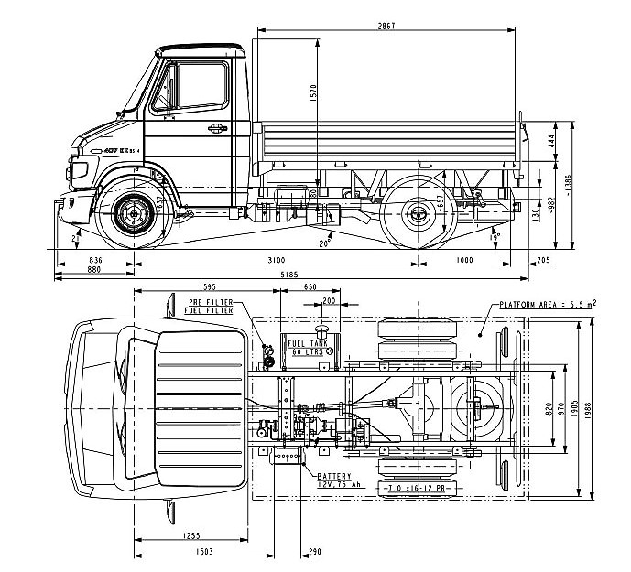

S. No | Detail of work | Specification
 | Body | Body Dimension: Length 2.867 m X Width 1.988 m X Height 2.4 m  Container Floor: MS Sheet 2.00 mm  Side Panel /wall: MS Sheet 1 mm with corrugation  Body Runner: MS Sheet 4 mm  Hydraulic Door/ramp: MS Sheet 1.6 mm  Mudguard: 1.6 mm with rubber flap  Secondary Exit: An exit door with locking mechanism (on both sides of the door) towards the driver side of the side wall. The dimension of the door to be 0.75m Width X 2m Height.  Floor of the vehicle to have rails with locking system for facilitating movement of the cage from ramp to body while loading/ unloading.  The roof of the vehicle with telescopic 360-degree rotating search light and emergency vehicle hooters on the top of the vehicle. (500,000 Candle Power, 5.5 Amps, Weatherproof for Land and U.V. Ray and Salt Water Resistant)  Sound proofing of the body/cabin to reduce outside noise up to 100db, to reduce overall stress on the animal.  Lighting facility on the roof of the vehicle to illuminate the entire cabin for general viewing and conducting small surgeries on the operating table.
 | Multimedia System | Outdoor TV screen (40” or above) with Speaker system embedded on outer wall on the passenger side, the screen is protected with shatter proof glass and extendable PVC shade for conducting awareness programmes.  - Mic and port to connect the mic  -HDMI and USB Port on outside for connecting with external devices  -High Output speaker system (10000 W)  The entire system to be weatherproofed to avoid damage in rough conditions.
 | Air conditioning system | Air conditioning system with sufficient power to be added for maintaining the temperature of the entire cabin.
 | Water system | PVC water tank with the capacity of 200 litre placed on the top of the container with water tap and wash basin with drainage facility inside the vehicle.
 | Transport Cage | Cages may be made of stainless-steel pipe (without shine) or metal support frame and Fibre-reinforced plastic sheets to cover the sides to reduce any injury to the animal caught.  - Cage Dimension (According to CZA Guidelines): Length 1.95m X Width 0.75m X Height 105m  - Frame: MS Angle 40mm X 40 mm X6 mm  - Sides: Fibre reinforced plastic steel sandwich with cover of 3mm thick Iron sheet.  - Floor: 2mm thick corrugated metal sheet with 20mm diameter drainage holes. Two removable trays to be provided below the floor to receive urine and excreta.  - Four rubber wheels at the base of the cage for loading and unloading cage. The wheels to be placed in the rails with locks to restrict movement after loading on the vehicle.  - Roof: Fibre reinforced plastic steel sandwich. Two windows for viewing and darting on the top towards both ends.  - Doors: 12mm MS bar should be welded with frame and covered with Fibre reinforced plastic steel sandwich. Bolt chain system for closing and opening the doors.  - Wireless CCTV camera to be installed inside the cage with night vision capability. Video to be shared remotely (on mobile) and also on the screen in the driver’s cabin where the veterinary doctor can perform the health monitoring of the animal in the cage.
 | Seating | Foldable Seats with non-absorbent military grade padding(weatherproofed) should be fixed on both sides inside the vehicle. They should be folded to the body of the container conveniently.  Dimension: sitting plank Length: 1.82m, Width 0.45m  Load bearing capacity: 500 KG
 | Cupboard | Lockable PVC wooden cupboard with three shelves. The middle shelves to have two lockable sliding drawers for keeping medicines and drugs immobilization guns, accessories, medicines, books, records, and other monitoring equipment and should be designed towards the driver end opposite to secondary exit. Wash basin with tap to be installed below the cupboard with connection to water tank.
 | Hydraulics system on the door | The hydraulics system for lifting the cage from ground level and load it inside the vehicle to be attached to the door with the capacity of lifting above 1 tonne. The movement of the door to be vertical with a locking system.  Control panel to operate the hydraulic system to be embedded on the side wall (towards the rear end) with locking mechanism.
 | Mini operation theatre | A foldable stretcher convertible to operation table to be fitted at an appropriate place.
 | Tool box | To be placed in the driver’s cabin:  - Automatic motorized air-pump  - Mechanical Jack  - Puncture repair kit  - 3 Pieces Double Open-End Spanner of Size (8x10, 13x16, 18x21 mm).  - 1 Piece Hexagonal Key 08.  - 1 Piece Screw Driver 806.  - 1 Piece Wheel Spanner 24x27 A/F.  - 1 Piece Tyre Lever (Chrome Plated).
 | List of accessories to be installed in the vehicle | - First Aid Kit for Humans.  - Refrigerator (up to 52 L) for medicine storage  - Oxygen cylinder (above 10 L)  - Vehicle GPS Tracker with remote tracking option

3. Vehicle indicative sketch
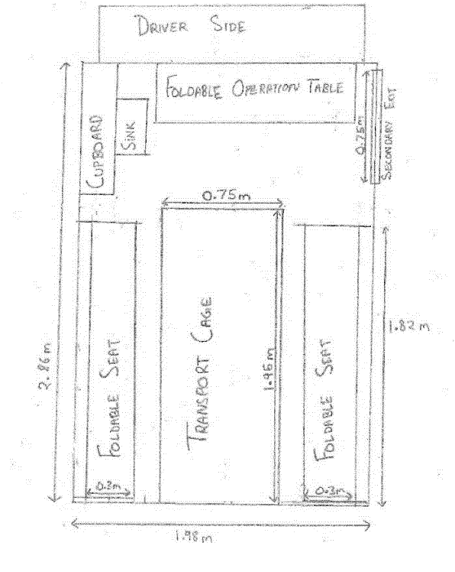

Annex 1B: Technical Specifications for Elephant Rescue Vehicles

- Vehicle Model: Mahindra Blazo X 25 CBC 5000, 10-Wheeler Truck
S. No | Items | Quantity
1 | Mahindra Blazo X 25 CBC 5000, 10-Wheeler Truck | 1

- Vehicle Diagram and Specifications
GVW | 25 Tonne
Load Carrying capacity | 17.773 Tonne
Wheelbase | 5000mm
Cabin length | 2270 mm
Load body length | 6716 mm

3. System Design and Philosophy:
S. No | Detail of work | Specification
 | Lifting Container | Side Walls: Dimensions to be Length 5.18m X Width 2.436m X Height: 2.43 m  Outer Frame of the wall to be constructed 100*40*6 mm³ Channel with inner support of 75*75*2.5 mm³ channel. The outer layer of the container walls to be of MS 3 mm with 1200 Mega Pascal tensile strength and inner side of the body wall to be lined 35 mm compressed plywood board.  Sliding window for monitoring at a height and dimension to coincide with window of Animal Health monitoring cabin.  Floor: The floor to be made with 125 mm ISO channel with MS 10 mm covered and inside to be lined with 35 mm thick compressed plywood. 8 Drainage holes of 5cm diameter to be made on the floor towards the sides at equidistant locations.  The floor of the container to also have 4 holes of 0.15 m X 0.15 m, two in front of the vehicle with 1.21 m distance and two towards the end of the container. The distance between the holes in front and end to be 2.74 m. The holes on platform to superimpose on the holes on chassis platform floor.  All the screws and nails to be placed carefully, avoiding any sharp edges on the inner wall of the container.  Holes on the side wall towards both end to be made for restrain the animal (Please refer to the images below). Hooks connected to chassis on the sides of the vehicle coinciding with holes of the side wall to be installed for restraining the elephant. The hooks to be made to with appropriate material to withstand immense pressure from restrained elephant.  The roof will open with provision of retractable wire mesh frames on the top of the container, so that the truck can be covered as per requirement.  Container Door: Double door with lateral movement of dimension (Height/Length 1.2 m X Width 2.06 m) made with MS 3mm chequered sheet with frame of MS channel.  There should be two permanently fixed ladders till the roof level, on the lateral walls one at the position of the front and another at the rear position of the lifting container. (Refer to image 1)  There should be two small windows on each lateral wall at the foot level where there are holes at the floor so that the restraining ropes may be manipulated during the transport if required. (Refer to image 2)  The inner walls of the lifting container should be as smooth as possible with no joints and sharp edges so that elephant doesn’t get anything to grasp and pull or manipulate or injure itself.
 | Hydraulic system | 4 Hydraulic retractable pillars at the four corners of the container with a lifting capacity of 4 tonnes each. The control panel to be located towards the front of the container on passenger side.  Winch system: Semi-automatic winch with breaking system to be installed at the top the container towards the drivers end. The capacity of winch to be up to 8 tonnes.  The panel for controlling the winch to be embedded on the side wall of the container. A small viewing slider window of dimension 30cm X 30cm to observe the animal being loaded to be placed near the panel for efficient control.
 | Chassis | The platform floor should be made with chequered metal plates of 5 mm thickness with truck chassis flatbed twist lock at four corners to lock lifting container to chassis.  Platform to have 4 holes of 0.15 m X 0.15 m, two in front of the vehicle with 1.21 m distance and two towards the end of the container. The distance between the holes in front and end to be 2.74 m. The holes on platform to super impose on the holes on container floor.
 | Shower system | Water Tank:  PVC Water tank with capacity of 200 litres to be placed above the animal health monitoring cabin. Small one Hp pump to be connected to the outlet to increase the water pressure.  Shower head to spray water to elephant:  Overhead Shower (Overhead Shower ø100mm Round Shape Multi Flow (ABS Body Chrome Plated with Grey Face Plate) with Rubit Cleaning System.
 | Animal Health Monitoring Cabin | Dimensions to be Length 1.52m X Width 2.43m X Height 2.13 m  The animal health monitoring cabin to be permanently constructed behind the driver’s cabin on the chassis with 1.3 mm corrugated MS sheet.  This cabin would have Jump seats for two people facing towards the container, Lockable cupboard for keeping tranquilization and other monitoring equipment, wash basin with water tap on one side and grilled window for ventilation on the opposite side of the door.  Artificial lighting source to be fixed for better visibility inside cabin.  The container wall facing the cabin needs to have sliding window at a height of 1.37 m with dimension of 0.45m X 0.15m for observing the animal.  Door: Dimension Height 1.82 m X Width 0.91, made with 1.3 mm corrugated MS sheet with locking system.
 | List of accessories to be installed in the vehicle | Inter Com (Speaker, Mic and CCTV camera with Video display also)  Speaker and Mic: Two-way audio with noise cancellation feature. To be installed in Animal health monitoring cabin and Drivers cabin.  Wireless video camera: Infra-red and Night vision capability with 1080p HD video recording. To be installed in in the container protected by shatter proof gorilla glass to avoid damage.  Intercom: Wi-Fi Connectivity (802.11.b.g.n) for Local and remote feed option.

- Vehicle Indicative sketches
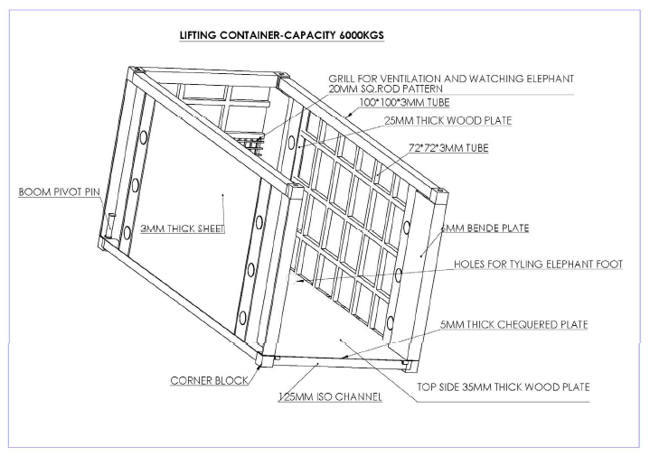
- Vehicle Indicative Images
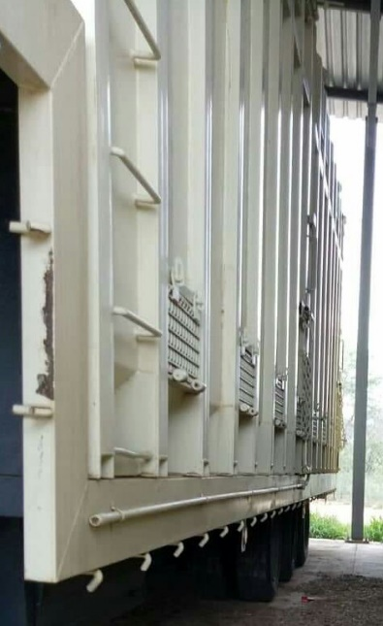
Figure 1 Image showing permanent ladder on the outside of the lifting container.

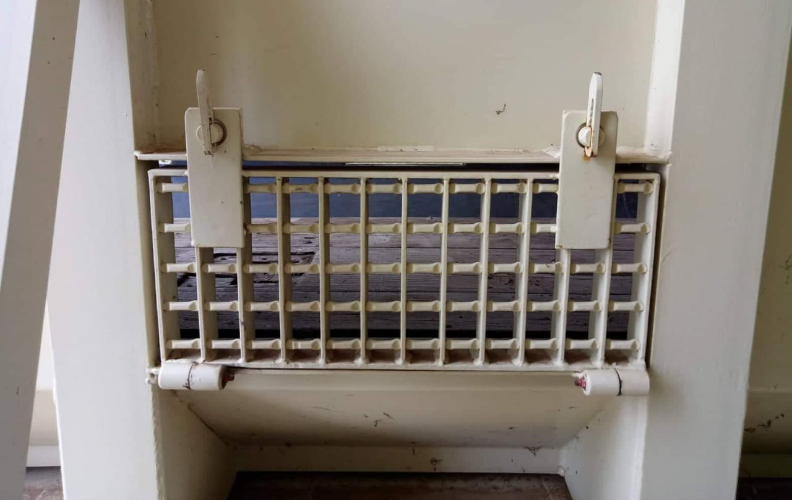
Figure 2 Image showing monitoring windows on the side of the lifting container.

Declaration by the bidder:

I/ We hereby confirm that all the specification given above has been properly understood and agree to supply the vehicles conforming to the required standard / specification.

(Signature of Bidder)

Seal/ Stamp and Date:

Annexure 2: Covering letter

Covering Letter
(To be submitted along with the Proposal/bid on company’s Letter Head)

M/s …..……………………………………..
…………………………………………
…………………………………………
…………………………………………
…………………………………………

To,
The Head of Procurement
GIZ Office, 46, Paschimi Marg
Vasant Vihar, New Delhi – 110 057

Subject: Offer in response to Bid No. 91134392 (fabrication & assembly, testing and delivery of Animal Rescue & transport Vehicles at selected locations in India)

Dear Sir/ Madam,

I/We the undersigned hereby offer to execute the scope of work and accordingly submit our offer in full compliance with terms & conditions of the bid.

The bid is being submitted as per the instructions mentioned in the tender documents.

(Signature of Bidder)

Name of the Contact Person
Mobile Number
Email Id
Land line Number, if any
Office address

Annexure 3: Declaration by the bidder

Declaration by the bidder (to be submitted along with the bid)

I/We the undersigned (herein after referred to as manufacturer) having fully understood the nature of the work and having carefully noted design, specification, terms and conditions, etc. as mentioned in the bid document do hereby declare that,

- All the requirements of the bid document have been understood properly and accordingly agree with all provisions of the bid document and accept all risks, responsibilities and obligations directly or indirectly connected with the performance of the bid.
- All the relevant information with regard to proper execution of the proposed work have been understood, with respect to the proposed specifications, its intended end use, availability of required materials and labour etc.
- Are capable of executing and completing the work as required in the bid and is financially sound to execute the scope of work as per the work execution schedule. We have sufficient experience and are competent enough to perform the contract up to the satisfaction of GIZ. We also give the assurance to execute the scope of work as per the specifications, terms and conditions on award of order.
- We have no collusion with other bidders, any employee of GIZ or team engaged in executing the scope of work.
- We have not been influenced by any statement or promises by any employee of GIZ or anyone from the team engaged by GIZ but only by the bid document.
- We are familiar with all general and special laws, acts, ordinances, rules and regulations of the Municipal, District, State and Central Government that may affect the work, its performance or personnel employed therein.
- We have never been debarred to undertake similar work by any Government undertaking/department.
- The submitted offer shall remain valid for acceptance for 30 days from the last date of submission of bid.
- All the information and the statements submitted with the bid are true to the best of knowledge.

(Signature of Bidder)

Name:

Seal/Stamp:

Date:

Annexure 4: Document Submission
- Checklist
Bidder should confirm that following documents has been submitted along with the bid.
Sl. No | Documents | Yes | No
 | Covering letter as per prescribed format (Annexure 2)
 | Declaration on Company’s letter head with complete contact details as per prescribed format (Annexure3)
 | Agreement of Technical Specification (Annexure 1) Signed and stamped
 | Price bid as per prescribed format (Annexure 6)
 | Delivery Schedule: Total time frame required for supply of vehicles (Annexure 5)
 | Filled checklist (Annexure 4)
 | Further documents required as per section 2 below
- Bidders to provide following information and need to attach documentary evidence in support of each of them
Sl. No | Description | Relevant document to be submitted | Documents Submitted
 |  |  | Yes | No
 | The bidder should have a minimum experience of 03 years in fabricating animal rescue vehicles, using modern technology such as hydraulics, being used by the Forest Departments/ Protected areas in any part of India. | - Certificate of Incorporation or any other document for registration or partnership deed  - 3 or more years old work orders for fabrication of rescue vehicles in the name of the bidder  - A letter from the relevant Forest Department/ officer, where the fabrication work was done
 | Annual turnover of at least 100% of the quoted amount in the last two financial years. | Copy of audited statement by CA.
 | It should possess the documents showing registration e.g. GST, PAN, etc. Self-attested copy of the documents should be furnished by the bidder along with the bid. | Copy of Pan card  Copy of GST number
Signature of the bidder

Name:

Seal / Stamp

Annexure 5: Delivery Schedule

Overview

Sl. No | Description | Expected Plan (GIZ) | Plan Proposed by the bidder
 | Date of Purchase Order / Award of Contract | D0 (Day 0)
 | Complete Delivery of Vehicle and associated training and registration at project site | D0 + 120 days

Detailed Schedule

Sl. No | Tentative Delivery Schedule | Expected Plan (GIZ) | Plan Proposed by the bidder
 | Procurement and inspection of material | D0 + 15 days
 | Fabrication and delivery of the vehicles | D0 + 60 days
 | Testing of all vehicles at the Project site | D0 + 80 days
 | Training to the end-user at the Project site | D0 + 120 days

Name of the Supplier:

Signature & Stamp

Date

Annexure 6 (A & B) : Price bid submission

Separate excel sheet enclosed with the tender document.

